Auto Mouse
User guide

Auto Mouse

Auto Mouse is a software product to help computer users reduce the amount of hand-strain associated with operating a computer mouse. It is designed to prevent and recover from computer-related RSI, and as tool for graphic artists and CAD users who need higher accuracy with complex mouse actions (such as drawing on a canvas).

Introduction

Auto Mouse is a program designed to relieve the use of the computer mouse by allowing the user to:

- Click the mouse using keyboard keys
When you begin to move the mouse, a small icon of a mouse will appear alongside your cursor. This is known as the Screen Mouse.
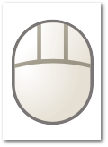
The Screen Mouse allows the user to click the mouse by using the keyboard keys. Pressing 1 will click the left button, 2 will click the middle button and 3 will click the right button. The keys can be changed via the Screen Mouse settings screen.
- Move the mouse using the keyboard keys
When the Screen Mouse is visible, the user can move it around using the keyboard arrow keys.
- Automatically click the mouse when the mouse stops moving
Alternatively, the user can elect to have a click issued whenever the mouse stops moving.

Auto Mouse starts automatically when the user logs on and continues to run seamlessly in the background.

Settings

To access the Settings, righ-click on the Auto Mouse icon found in the Task Bar Notification Area and select Settings. Alternatively, you can just left-click on the icon.

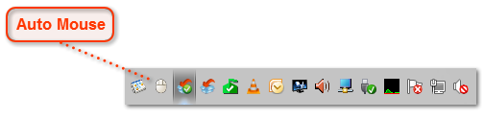

To close the Auto Mouse application completely, right-click and select Exit.

General Settings
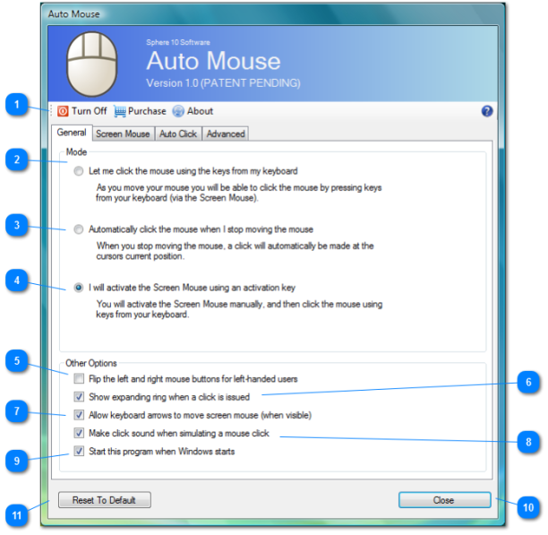

Toggle On/Off

This will toggle Auto Mouse on or off.

When on, the Auto Mouse will function with the selected mode.

When off, Auto Mouse sits in the background and does nothing.

To close the application entirely, the user needs to right-click and select Exit on the notification area icon.

Screen Mouse Mode

When this option is selected, the Screen Mouse will show whenever you begin to move the mouse and it will fade away when you stop moving the mouse.

When the Screen Mouse is activated, you can click the mouse keys by pressing keys on your keyboard.

This mode of operation allows you to perform complex mouse actions like clicks, double clicks, drag-and-drops without you physically clicking the mouse.

You can also move the mouse using the keyboard arrows (if the setting is enabled).

The settings to configure the Screen Mouse can be found in the Screen Mouse tab.

Auto Click Mode
When this mode is selected, the mouse will issue a click whenever the mouse stops moving.

The button and type of click can be configured in the AutoClick menu.

This mode of operation is less flexible than the Screen Mouse or Manual mode, but it does not require the keyboard to click the mouse, and may be suitable for users with trigger-finger RSI symptoms.

Manual Mode

This mode will require the user to manually activate the Screen Mouse using a keyboard key.

Then the user can use the click buttons using the Screen Mouse, just as in mode 1.

The user will then manually de-activate the Screen Mouse.

This mode is useful for Graphic Artists, or CAD-related applications to allow more accuracy in drawing mouse operations.

Flip Mouse Buttons
This feature flips the left and right mouse buttons to assist left-handed users use right-handed mice (or vice-versa).

Expanding Rings

When selected, an expanding ring will appear centered on where a click was simulated.

Keyboard Keys

This will allow the user to control the mouse cursor using the keyboard keys.

Click Sounds

This option will make a click sound whenever a mouse button is clicked down or up via the Screen Mouse.

This feature is recommended for users of financial-related applications so the user is alterted when a key is intercepted for the Screen Mouse as opposed to having that key enter a digit in a cell of spreadsheet for example.

Auto Start

If this option is selected, this will make the application load automatically when Windows stars.

Close Button

This will minimize the application into the notification area. To close the application, you must right click and select 'Exit' on the notification area icon.

Factory Settings
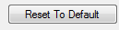

This option will restore all settings back to their default values determined by Sphere 10 Software.

Screen Mouse Settings
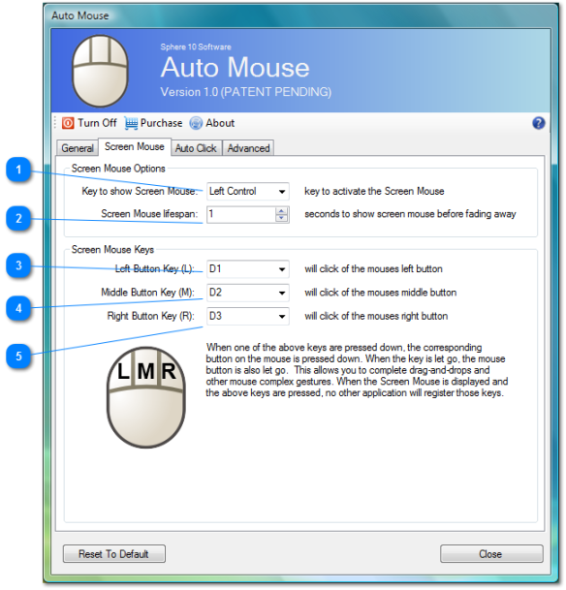

Activation Key

In Manual mode, when this key is pressed the Screen Mouse will Activate.

Lifespan

In Screen Mouse mode, this is the duration which the Screen Mouse remains visible when the mouse stops moving.

After that duration, the screen mouse will fade away.

Left Button Key

This key will simulate the left button of the mouse.

When this key is pressed down, the left mouse button is pressed down.

When this key is released, the left mouse button is released.

Middle Button Key

This key will simulate the middle button of the mouse.

When this key is pressed down, the middle mouse button is pressed down.

When this key is released, the middle mouse button is released.

Right Button Key

This key will simulate the right button of the mouse.

When this key is pressed down, the right mouse button is pressed down.

When this key is released, the right mouse button is released.

Auto Click Settings
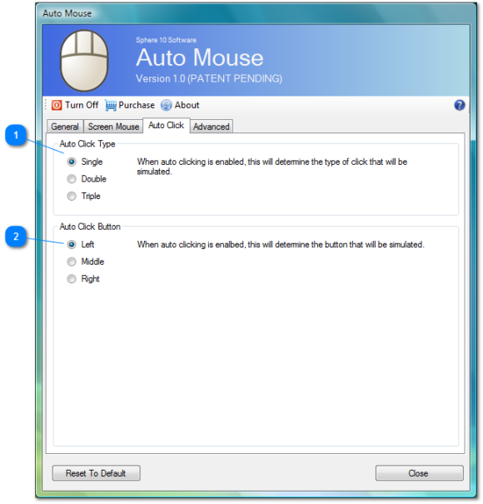

Auto Click Type
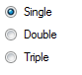

Auto Click Button
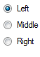

Advanced Settings
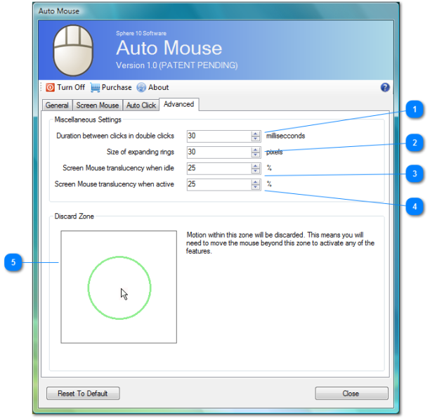

Interclick Duration

When Auto Click is enabled, this setting determines the interval between clicks when simulating a double or triple click.

Expanding Ring Size

This setting determines, in pixels, the radius of the expanding rings that are drawn around the click point when simulating a click event.

Idle Translucency

When the Screen Mouse is activated, as a result of mouse motion, this setting determines the translucency of the screen mouse.

It should be low, so that it does not obstruct the users view but high enough to be visible.

Active Translucency

When the user uses the Screen Mouse (via the keyboard), this is setting determines the translucency of the mouse as it becomes active.

Discard Zone

Motion within this zone will not trigger anything. This allows some fiddle room for the user before Auto Mouse activates.

For example, for the Screen Mouse to activate, the user will need to move the mouse beyond the green circle, otherwise nothing will happen.

For small screens this circle should be smaller. For larger screens, somewhat larger. The user should choose what he or she is comfortable with.

